TITLE: descriptive title of the paper. The title should be concise and not span more than 2 lines.
First A. Authora* and Second B. Authorb
Abstracts should not exceed
2 pages

a Rock Mechanics University, Sapporo, Japan
bRock Mechanics Measurement Ltd., Beijing, China
* first.author@rock.ac.jp (corresponding author’s E-mail)

(Abstract : text : Arial narrow 11 – Title : 13 )

Introduction :
Aria que aut ut ere lab id miliqui ipisquam cuptatur? Faceri consernam as con perum earum, voluptin conet ulloresti beaque nem intur, sequide litatis quat porit unt ut volluptis ma voluptatatio vent, ut maximpelis dolore dolorem quam undit aborrovitate nime dolupta tiuscim pelluptatur?
As et apicipsum qui num aperia pe nullesc ipsuntiam sequas rerepero ende in platur asitia nullo ea si omnihici doluptat volupta dis doloreictur?
Aximus aut dollecum recate et quos entem reiure velent, que derro consediscid et aut vero voluptiorum
et pedigenime re non nonseni hicius.
Iqui omnisci tasperum quodicienis sequi tem. Icium reriber ferrovi dellace provitet latus ut poribus porerunt faccuscit, que ex eium es in exerumet modis simet dit ellanit ipici ariant liquiae dolorum aut veruptatem reperfe ressus di dolo odic te lam landeniet quae desciet et quis molorepero verum hil inctiasima si veleniment pa nobit, quis cum faci omnimolorrum volorer ciendus, iliae quat volor sanducidi blam volorendis erum velecto in pa dolorum verisque idus.
Dolorrovid quam erehenti quibusd anihilique dolenda epelenis doloreic tessunt.
Aligent emporiat dolo quos eos etur autet quo debis moluptintur am, etur aut ratempori nulluptatus, illes rectatu sdaeris et odit, evel iliqui non pro blaborio et ani dolor aceprat atatur, impor suntias sequi il ipsaperovita vendae. Nati re, temperia natusdae net vendunt ut laut inciet duci odi nonse dipidereius audi idusand ignitae ipitium conem sitiis sam que perum ipis enis magnam sendam ipsam experore volum et reperferae sequi optat.
Em estio. Neque prepudio cus, conse voluptureped molorio dit rerovitiam arcit dus ratiis dolupitam volenditium quasitias que vendus acea ideruptae. Enim quiam intiis molorectur a nonsequiat plab idionsedi ullore enia core eveles eligendes sed ut laceres eculparum ium et omnimai orenis nulparu ptatemp orehent iorpos sum et adi iunducit quas aperi sam quo corporaturem suntibus.
Inihill oreperferum dolo quaspid maximinis duciur acit, sitates

Citations, tables and figures

Table 1 Some features of the porous rocks
Porosity (%) | Case | Water content |  | Water saturation  ratio (%)
 |  | (mass %) | (vol %)
54 | (a) | 0.50 | 0.12 | 2
 | (b) | 25.00 | 62.3 | 45
 | (c) | 13.0 | 0.69 | 90

Fig. 1.
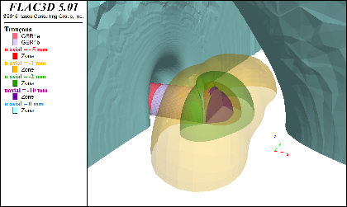
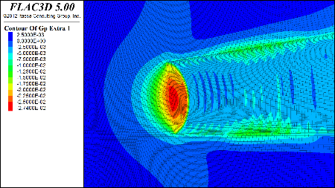

Fig. 1. Example of axial and isovalue in an underground gallery

Results and discussion

Conclusion

Acknowledgements
References: (Arial narrow 9)
Laouafa F, Prunier F, Daouadji A, Darve F (2011) Stability in geomechanics, experimental and numerical analyses. Int J Num Anal Meth Geomech 35(2):112–139
Diederichs MS (2003a) Manuel Rocha medal recipient rock fracture and collapse under low confinement conditions. Rock Mech Rock Eng 36:339–381
Souley M, Lafrance N, Auvray C, Labiouse V, Belem T (2016) An elastoplastic and viscoplastic model for porous geomaterials. In: Rock Mechanics and Rock Engineering: From the Past to the Future, Ulusay et al. (Eds). Taylor & Francis Group, London, ISBN 978-1-138-03265-1:481-486
Jaeger JC, Cook NG, Zimmerman R (2009) Fundamentals of rock mechanics. Wiley, New York
McGinley JRA (1969) Comparison of observed permanent tilts and strains due to earthquakes with those calculated from displacement dislocations in elastic earth models. PhD Thesis. Calif Inst Tech, Pasadena, California

